**Nama : Aliyaqara estatika dan Devika Silpiana**

**NIM : 1127050008 dan 1127050036**

**Kelas : IF D-G**

Class Diagram :

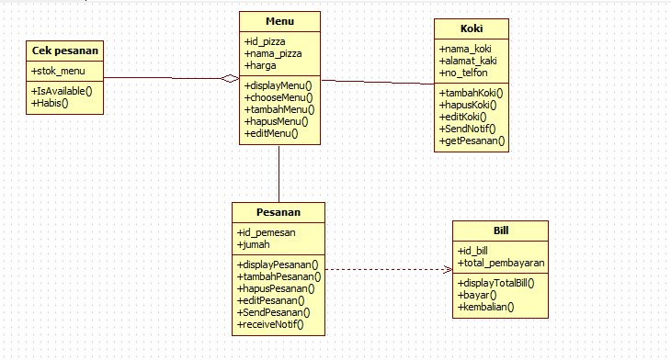

UseCase diagram :

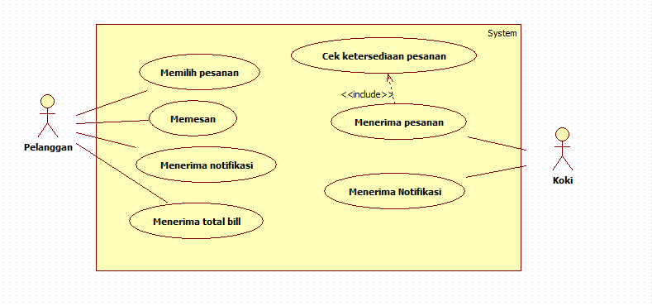

Sequence diagram :

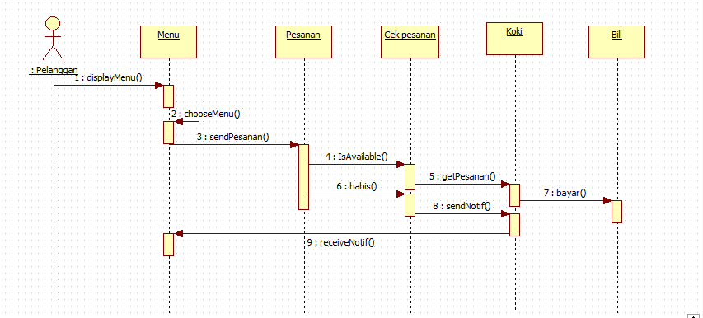

Activity diagram :

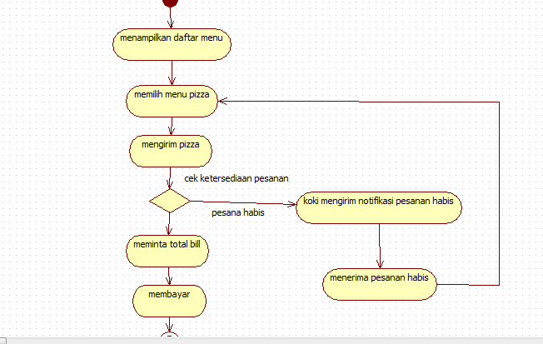

State diagram :

